SonarQube setup

Download Sonarqube community 🡺 Extract in C Drive 🡺SonarQube as foldername 🡺 Within that folder Extract it 🡺   
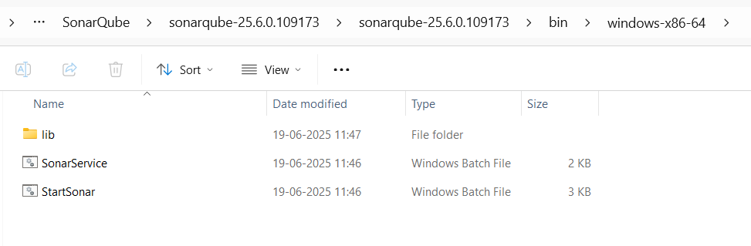

Open command prompt in this location

* Run below Commad to start the Sonarqube
* StartSonar.bat
* Port 🡺 localhost:9000
* Default credentials are admin,admin
* Change the password

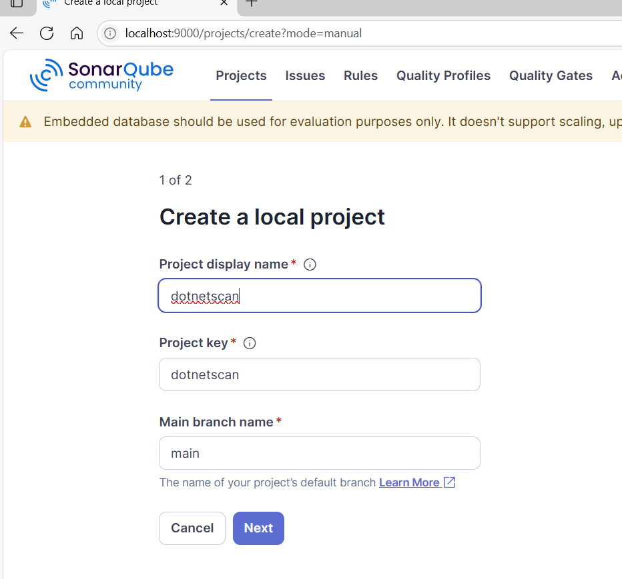

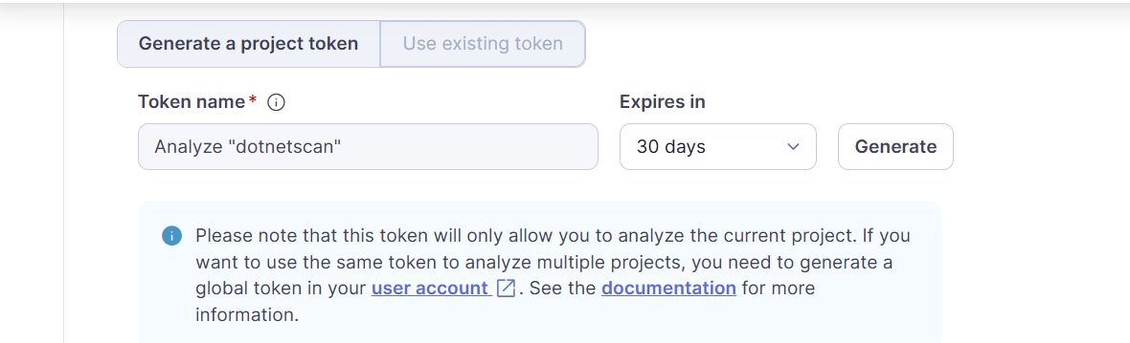

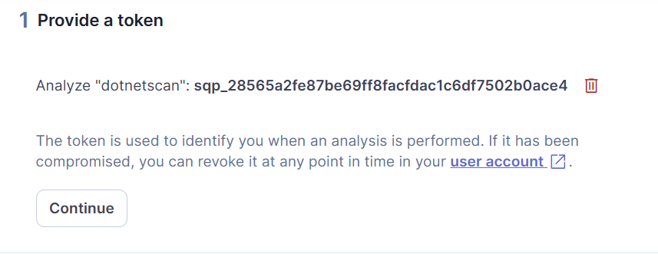

"dotnetscan": **sqp_28565a2fe87be69ff8facfdac1c6df7502b0ace4**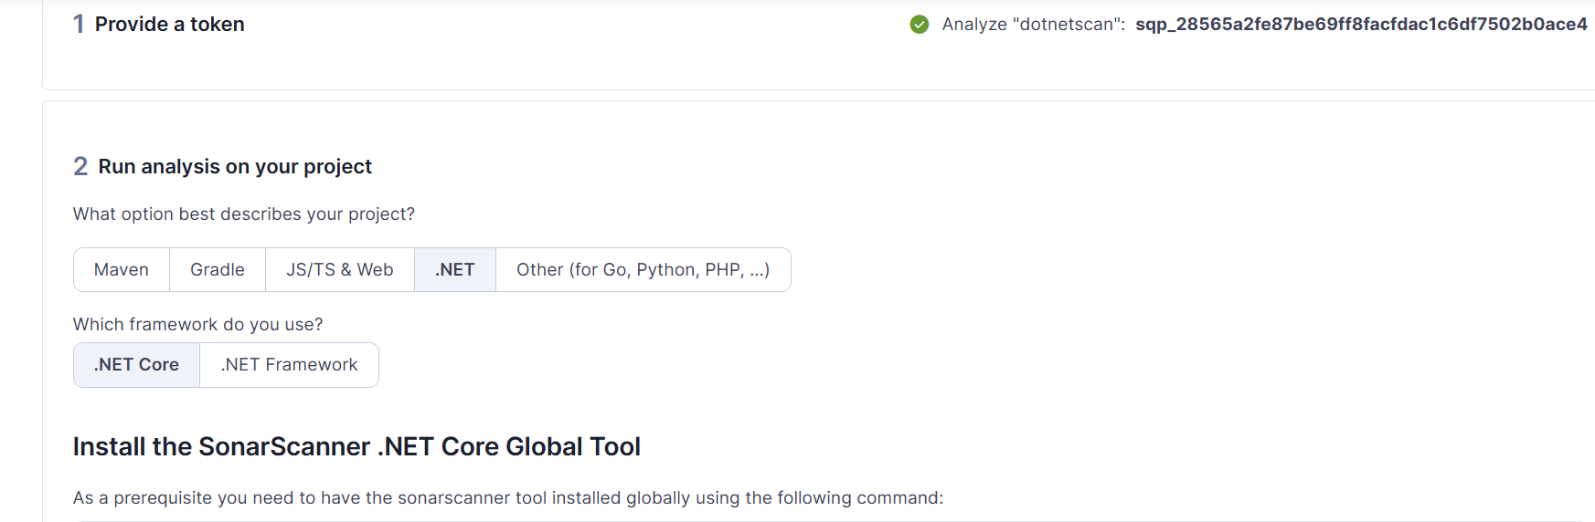

**Downlload sonarscanner**

[**SonarScanner for .NET installation | SonarQube Community Build Documentation**](https://docs.sonarsource.com/sonarqube-community-build/analyzing-source-code/scanners/dotnet/installing/)

[SonarScanner for .NET installation | SonarQube Community Build Documentation](https://docs.sonarsource.com/sonarqube-community-build/analyzing-source-code/scanners/dotnet/installing/)

Download and extract

Create one separate folder as Sonarscanner 🡺Paste the extracted folder inside

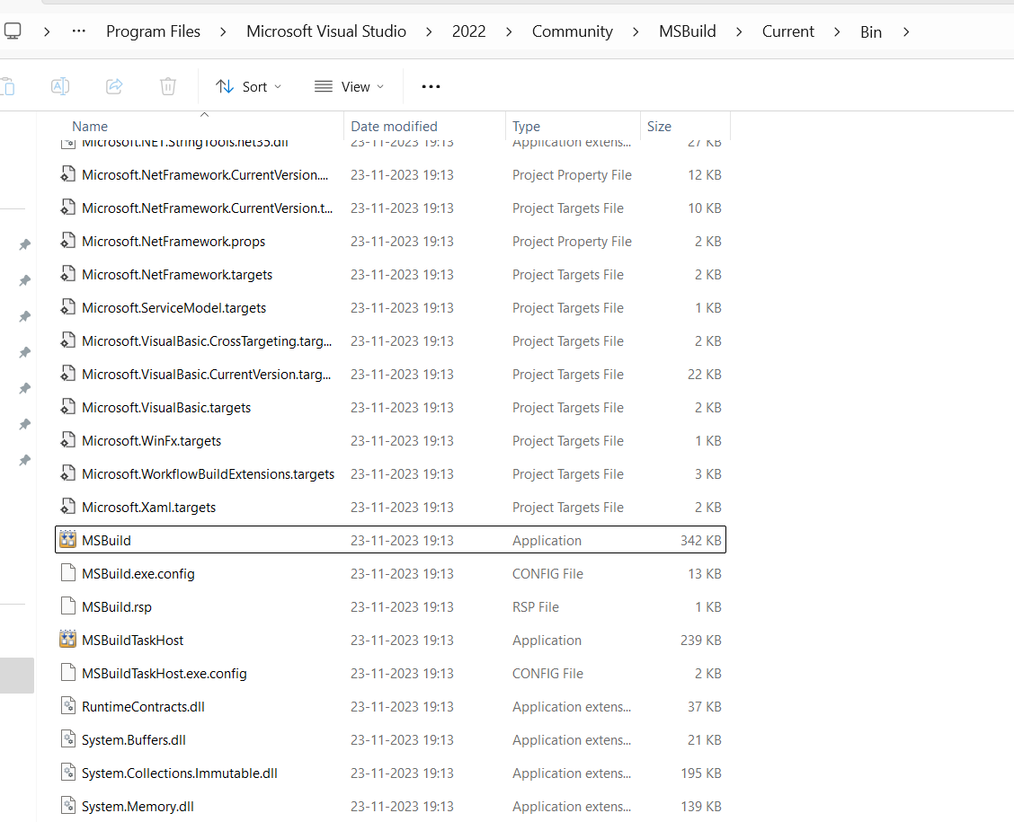

We need to set the environmental variables for these too

C:\Program Files\Microsoft Visual Studio\2022\Community\MSBuild\Current

C:\SonarScanner\sonar-scanner-10.2.0.117568-net\sonar-scanner-5.0.2.4997\bin